Setup 2 Thermal Step-Response Analysis
Measured versus theoretical transfer-function response and time constants
Data record | Setup2.txt
Model forms | FOPDT, SOPDT, and Padé [2/2] rational delay forms
Analysis date | 6 August 2026

Key result. The measured samples are compared with first-order and two-pole thermal models using exact dead time. Padé [2/2] forms are also evaluated as rational approximations for software that cannot represent a pure delay. The two-pole exact-delay model remains the preferred time-domain representation.

1. Response-time comparison
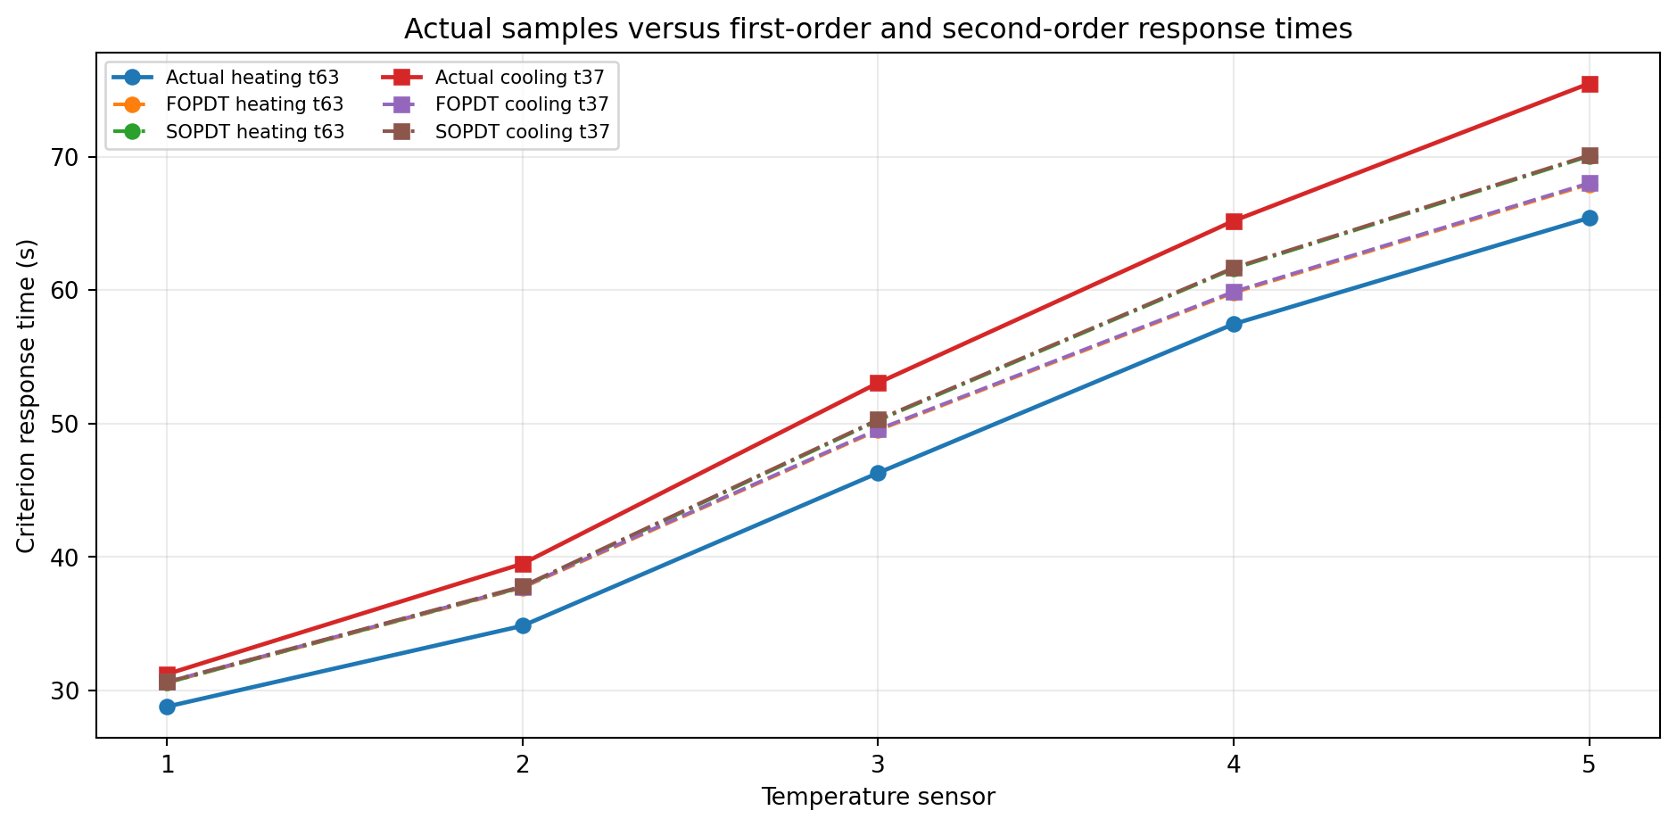
Figure 1. Criterion response times obtained from the actual samples, the first-order model, and the second-order model for heating and cooling.

Sampled and derived dataset
Figures 2 and 3 are both limited to the first 600 s after the 100% heater step. Figure 2 shows the synchronized raw temperature record, and Figure 3 shows the derived ambient-corrected dataset for each sensor. In every derived-data panel, circular markers represent actual samples, dashed curves represent the first-order estimate, and dash-dot curves represent the second-order estimate.
$$θ_{i}(t) = [T_{i}(t) - T_{ambient}(t)] - {baseline}_{i}(t)$$
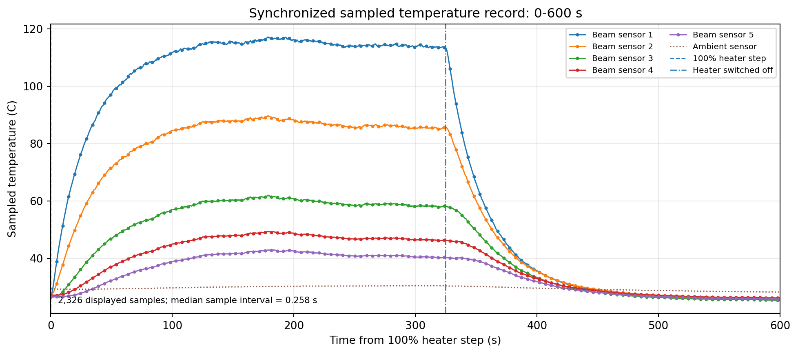
Figure 2. Raw sampled temperature record from 0 to 600 s. Vertical lines mark the 100% heater step and heater switch-off.

2. Identification method
The heater command changes from 0% to 100%, remains active for approximately 324.8 s, and then returns to 0%. The sensor output used for identification is the ambient-corrected temperature rise. A centered moving average of approximately 2 s is used only for locating practical threshold crossings. Both FOPDT and SOPDT model outputs are evaluated against the complete unsmoothed derived dataset.
$$G_{FOPDT,i}(s) = \frac{K_{i} exp(-L_{i}s)}{(τ_{i}s + 1)}$$
$$G_{SOPDT,i}(s) = \frac{K_{2,i} exp(-L_{2,i}s)}{(τ_{slow,i}s + 1)(τ_{fast,i}s + 1)}$$
For the first-order model, one time constant corresponds to 63.2% of a rising step and 36.8% of a falling step; with dead time, the ideal heating crossing is approximately L + tau. A two-pole system has two fitted time constants, so its comparable response time is obtained directly from the SOPDT curve at the same 63.2% or 36.8% criterion.
In this report, practical means a direct threshold crossing obtained from the sampled sensor response. First-order and second-order theoretical values are empirical transfer-function predictions fitted to the experiment; they are not first-principles finite-element or heat-equation solutions.

Derived dataset and model overlay
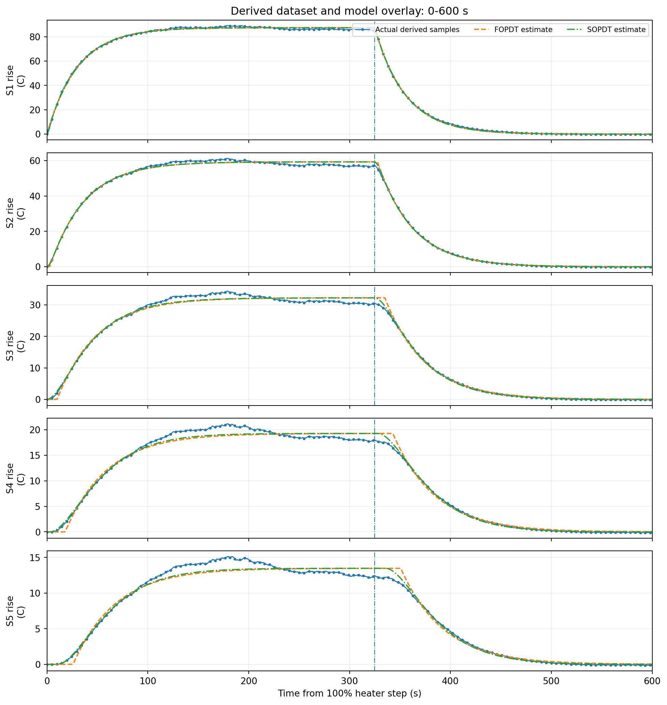
Figure 3. Derived ambient-corrected samples overlaid with FOPDT and SOPDT estimates from 0 to 600 s. Markers are shown at reduced visual frequency; all synchronized samples in this interval are displayed.

Padé representation of the transport delay
An exact factor exp(-Ls) is the most accurate representation of a measured pure delay in the time domain. A Padé approximation does not identify additional physics; it replaces the exponential delay with a rational numerator and denominator so that the model can be implemented in standard state-space or transfer-function software.
$$e^{-Ls} ≈ \frac{1 - (\frac{L}{2})s + (\frac{L^{2}}{12})s^{2}}{1 + (\frac{L}{2})s + (\frac{L^{2}}{12})s^{2}}$$
Figure 4 compares exact-delay and Padé [2/2] forms. The Padé curves closely track the exact SOPDT curves, especially where the fitted residual delay is small. They do not materially improve agreement with the samples. The improvement over the first-order model comes from the second thermal pole, not from Padé rationalization. Padé models may also produce a small nonphysical inverse response before the delayed rise, because their right-half-plane zeros approximate phase lag.
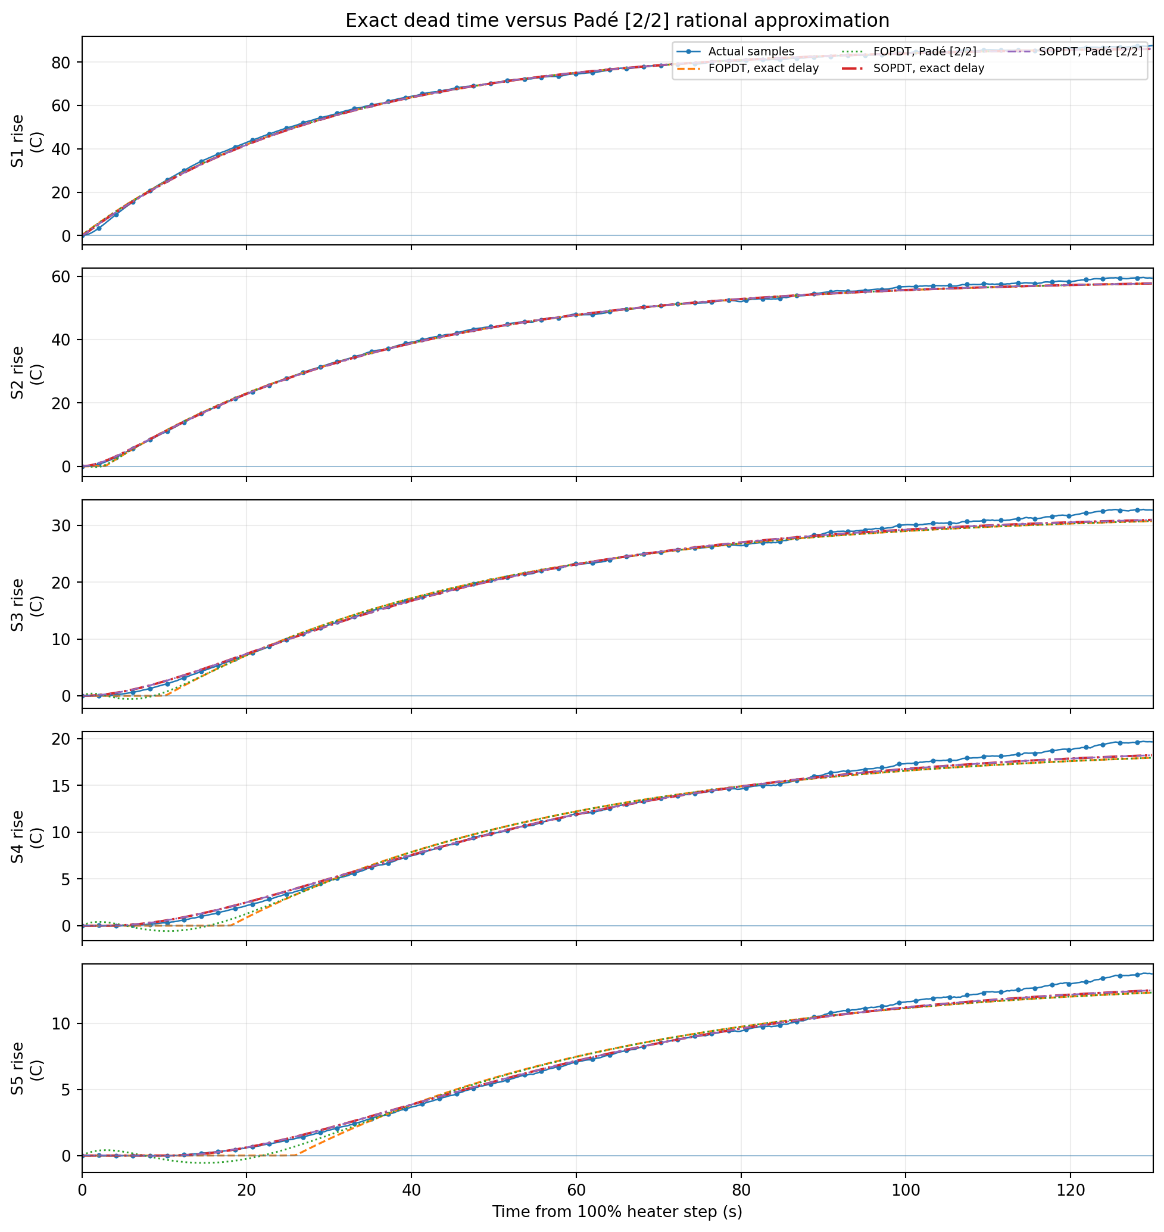
Figure 4. Actual samples, exact-delay FOPDT and SOPDT models, and their Padé [2/2] rational delay approximations during the first 130 s of heating.

Padé fit comparison over 0-600 s
Sensor | FOPDT exact  RMSE (C) | FOPDT Padé 2/2  RMSE (C) | SOPDT exact  RMSE (C) | SOPDT Padé 2/2  RMSE (C) | SOPDT Padé 3/3  RMSE (C) | Padé 2/2 early  minimum (C)
1 | 0.831 | 0.831 | 0.834 | 0.834 | 0.834 | 0.156
2 | 1.040 | 1.040 | 1.014 | 1.013 | 1.013 | 0.029
3 | 1.025 | 1.024 | 0.892 | 0.892 | 0.892 | 0.004
4 | 0.898 | 0.896 | 0.743 | 0.743 | 0.743 | -0.003
5 | 0.785 | 0.784 | 0.674 | 0.674 | 0.674 | -0.030
Table 1. Fit comparison over the first 600 s after the heater step. Padé [2/2] and [3/3] approximate the fitted SOPDT delay but do not add a new thermal mode.

3. Transfer functions and measured comparison
Sensor | Distance  (mm) | K  (C) | L  (s) | tau  (s) | Heating t63  Actual / FOPDT / SOPDT | Cooling t37  Actual / FOPDT / SOPDT | R2  F / S
1 | 0.00 | 87.44 | 0.00 | 30.64 | 28.78 / 30.58 / 30.57 | 31.22 / 30.64 / 30.63 | 0.9997 / 0.9997
2 | 8.89 | 59.29 | 2.88 | 34.89 | 34.84 / 37.70 / 37.74 | 39.49 / 37.77 / 37.80 | 0.9990 / 0.9991
3 | 19.05 | 32.30 | 10.17 | 39.39 | 46.30 / 49.50 / 50.24 | 53.05 / 49.57 / 50.30 | 0.9967 / 0.9975
4 | 29.20 | 19.29 | 18.10 | 41.76 | 57.46 / 59.80 / 61.62 | 65.20 / 59.89 / 61.68 | 0.9930 / 0.9952
5 | 39.30 | 13.49 | 25.95 | 42.05 | 65.42 / 67.94 / 70.04 | 75.49 / 68.03 / 70.11 | 0.9891 / 0.9920
Table 2. Actual sample criterion times compared with FOPDT and SOPDT model crossings. R2 columns are first-order / second-order.

Second-order parameters and fit error
Sensor | K2  (C) | L2  (s) | tau slow  (s) | tau fast  (s) | RMSE FOPDT  (C) | RMSE SOPDT  (C) | RMSE reduction
1 | 87.37 | 0.00 | 30.43 | 0.20 | 0.635 | 0.637 | -0.3%
2 | 59.27 | 0.00 | 34.64 | 3.02 | 0.791 | 0.771 | 2.6%
3 | 32.26 | 0.00 | 35.61 | 12.69 | 0.777 | 0.677 | 12.9%
4 | 19.28 | 3.05 | 27.32 | 27.32 | 0.681 | 0.564 | 17.2%
5 | 13.48 | 10.72 | 27.67 | 27.67 | 0.595 | 0.512 | 14.1%
Table 3. SOPDT parameters and fit-error comparison. Positive reduction indicates a lower SOPDT RMSE.

Identified heater-to-sensor transfer functions
$$G_{1,F}(s) = \frac{87.44 exp(-0.00s)}{(30.64s + 1)}$$
$$G_{1,S}(s) = \frac{87.37 exp(-0.00s)}{(30.43s + 1)(0.20s + 1)}$$
$$G_{2,F}(s) = \frac{59.29 exp(-2.88s)}{(34.89s + 1)}$$
$$G_{2,S}(s) = \frac{59.27 exp(-0.00s)}{(34.64s + 1)(3.02s + 1)}$$
$$G_{3,F}(s) = \frac{32.30 exp(-10.17s)}{(39.39s + 1)}$$
$$G_{3,S}(s) = \frac{32.26 exp(-0.00s)}{(35.61s + 1)(12.69s + 1)}$$
$$G_{4,F}(s) = \frac{19.29 exp(-18.10s)}{(41.76s + 1)}$$
$$G_{4,S}(s) = \frac{19.28 exp(-3.05s)}{(27.32s + 1)(27.32s + 1)}$$
$$G_{5,F}(s) = \frac{13.49 exp(-25.95s)}{(42.05s + 1)}$$
$$G_{5,S}(s) = \frac{13.48 exp(-10.72s)}{(27.67s + 1)(27.67s + 1)}$$

4.1 Sensor 1 response
Distance | FOPDT tau | SOPDT poles | Heating t63 | Cooling t37 | RMSE F / S
0.00 mm | 30.64 s | 30.43, 0.20 s | 28.8/30.6/30.6 | 31.2/30.6/30.6 | 0.635/0.637
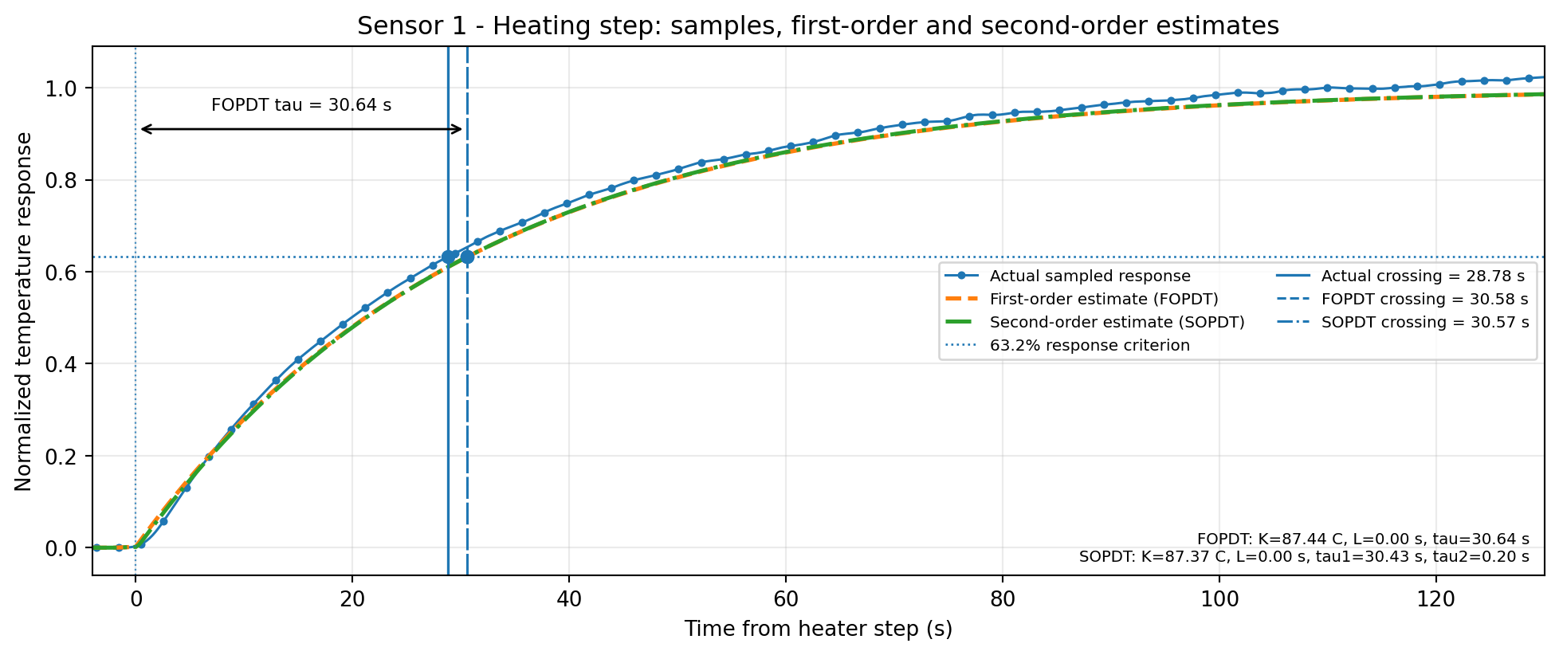
Figure 5. Sensor 1 heating step. Actual sampled response with FOPDT and SOPDT estimates; the 63.2% practical and model crossing times are marked.
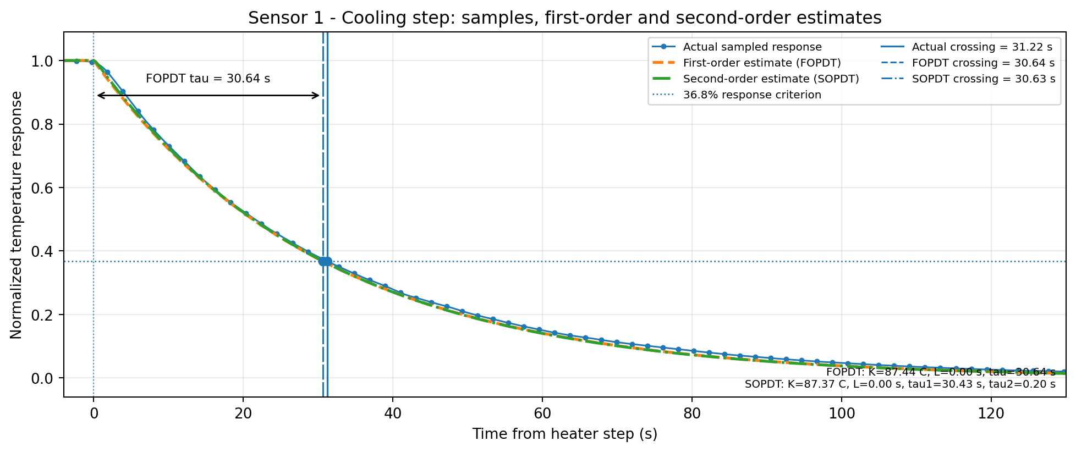
Figure 6. Sensor 1 cooling step. Actual sampled decay with FOPDT and SOPDT estimates; the 36.8% crossing times are marked.

4.2 Sensor 2 response
Distance | FOPDT tau | SOPDT poles | Heating t63 | Cooling t37 | RMSE F / S
8.89 mm | 34.89 s | 34.64, 3.02 s | 34.8/37.7/37.7 | 39.5/37.8/37.8 | 0.791/0.771
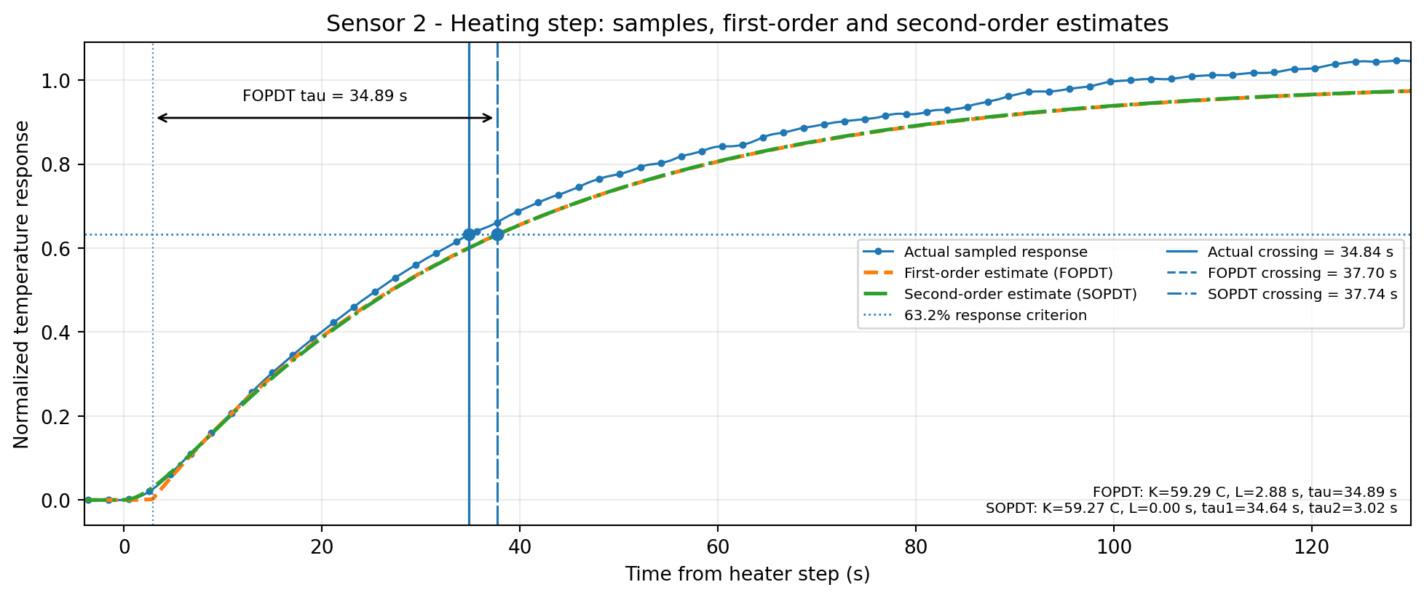
Figure 7. Sensor 2 heating step. Actual sampled response with FOPDT and SOPDT estimates; the 63.2% practical and model crossing times are marked.
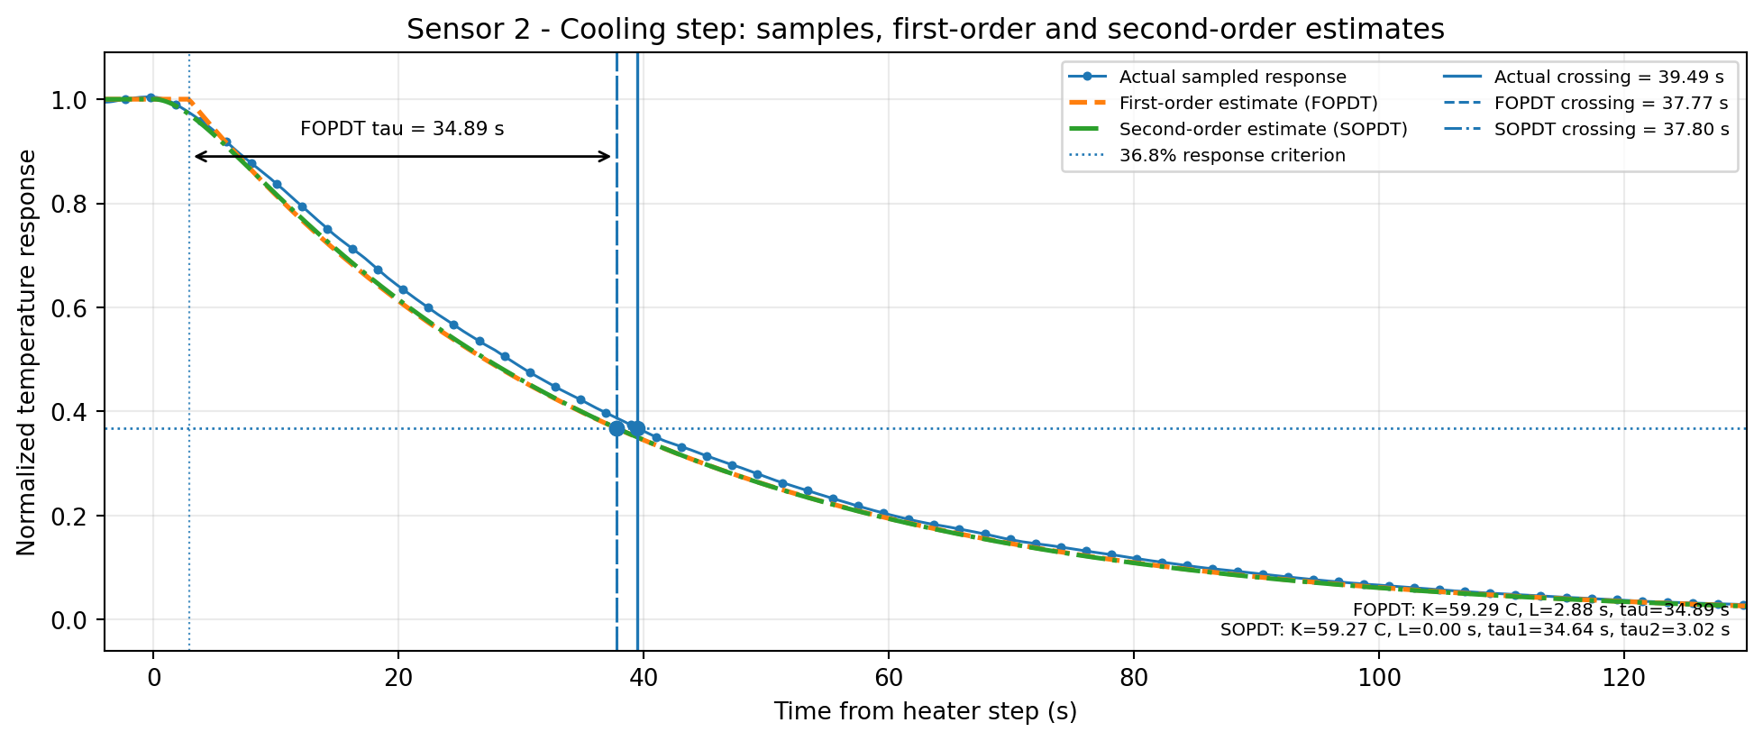
Figure 8. Sensor 2 cooling step. Actual sampled decay with FOPDT and SOPDT estimates; the 36.8% crossing times are marked.

4.3 Sensor 3 response
Distance | FOPDT tau | SOPDT poles | Heating t63 | Cooling t37 | RMSE F / S
19.05 mm | 39.39 s | 35.61, 12.69 s | 46.3/49.5/50.2 | 53.1/49.6/50.3 | 0.777/0.677
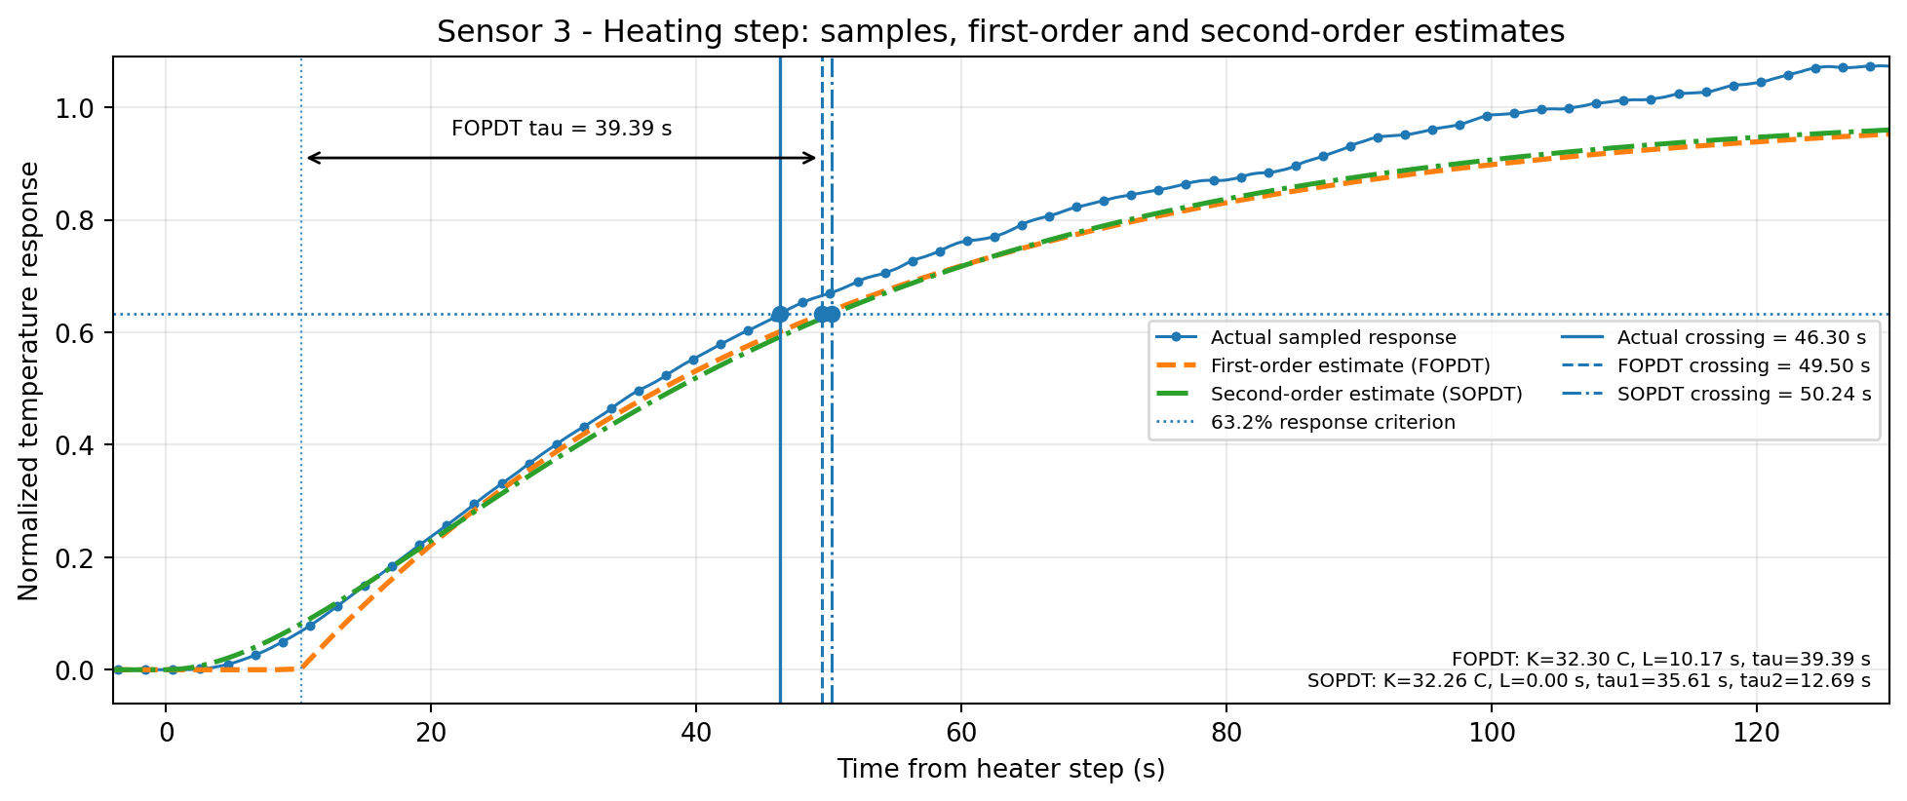
Figure 9. Sensor 3 heating step. Actual sampled response with FOPDT and SOPDT estimates; the 63.2% practical and model crossing times are marked.
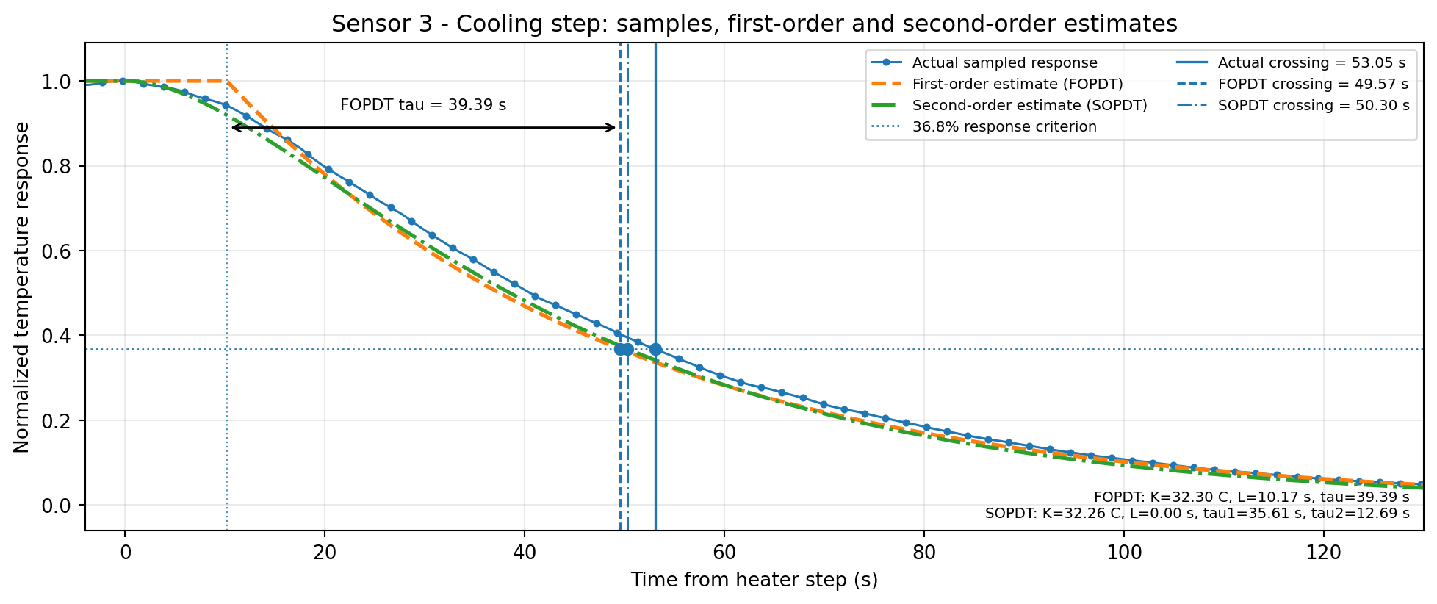
Figure 10. Sensor 3 cooling step. Actual sampled decay with FOPDT and SOPDT estimates; the 36.8% crossing times are marked.

4.4 Sensor 4 response
Distance | FOPDT tau | SOPDT poles | Heating t63 | Cooling t37 | RMSE F / S
29.20 mm | 41.76 s | 27.32, 27.32 s | 57.5/59.8/61.6 | 65.2/59.9/61.7 | 0.681/0.564
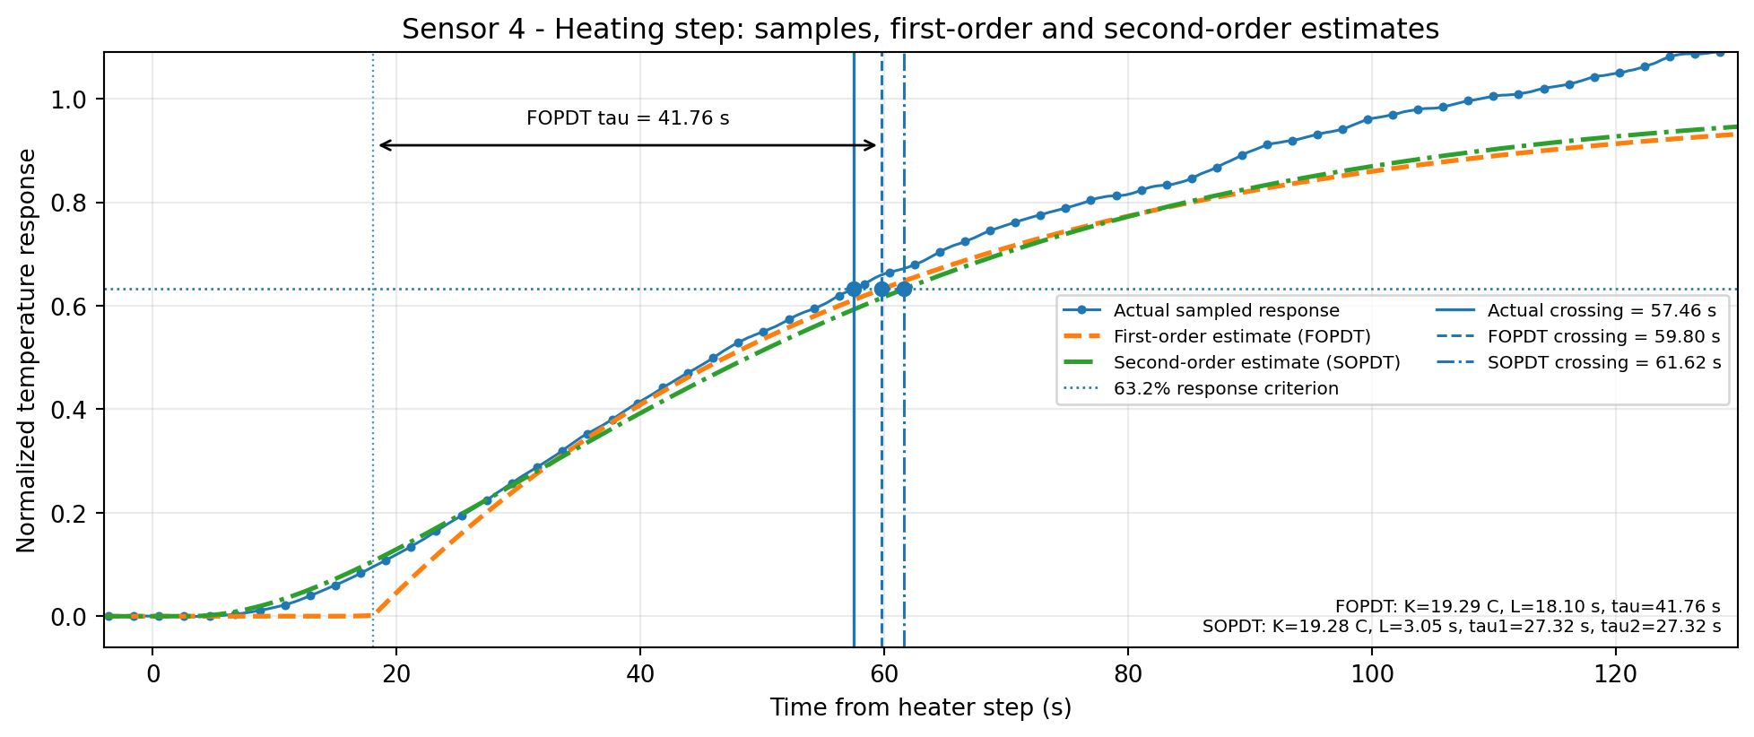
Figure 11. Sensor 4 heating step. Actual sampled response with FOPDT and SOPDT estimates; the 63.2% practical and model crossing times are marked.
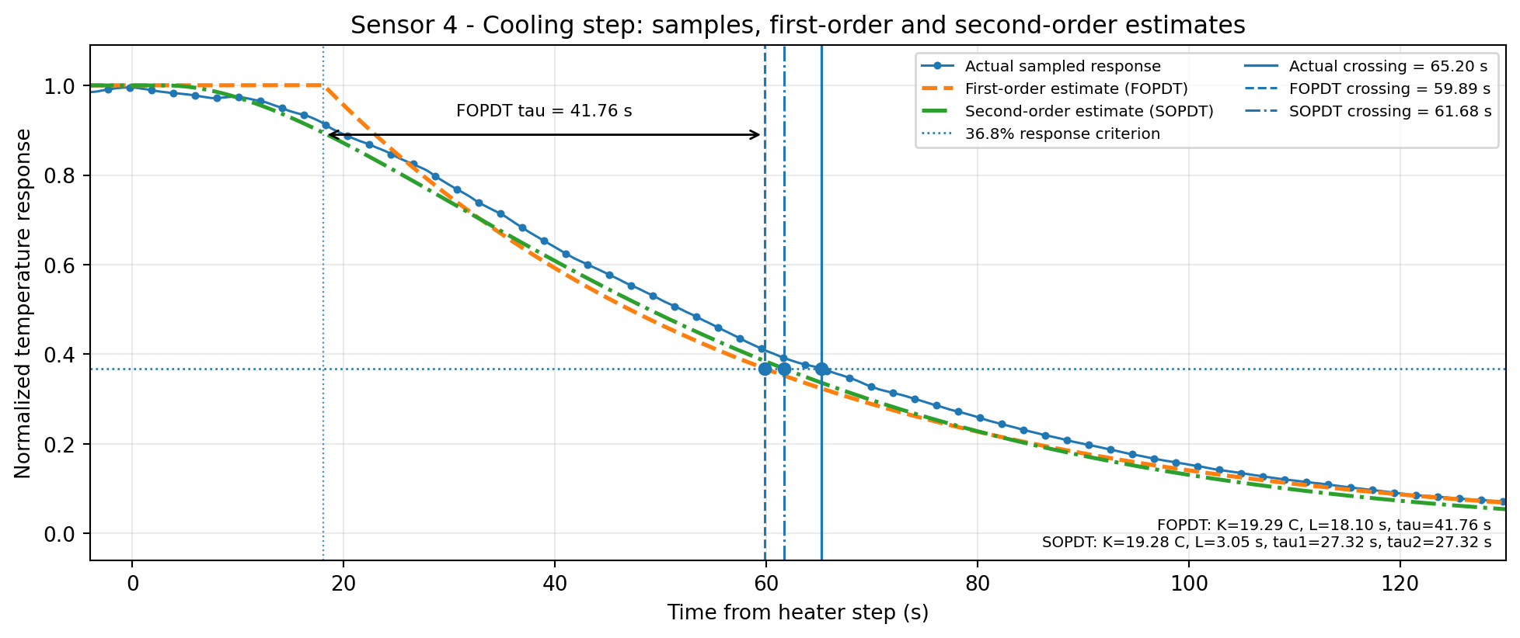
Figure 12. Sensor 4 cooling step. Actual sampled decay with FOPDT and SOPDT estimates; the 36.8% crossing times are marked.

4.5 Sensor 5 response
Distance | FOPDT tau | SOPDT poles | Heating t63 | Cooling t37 | RMSE F / S
39.30 mm | 42.05 s | 27.67, 27.67 s | 65.4/67.9/70.0 | 75.5/68.0/70.1 | 0.595/0.512
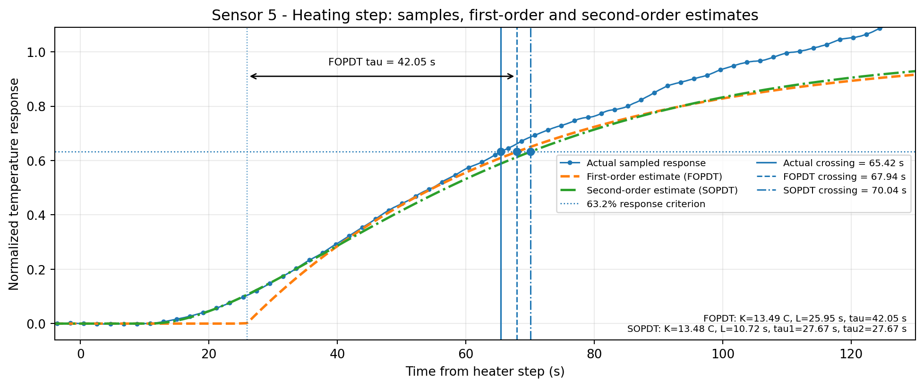
Figure 13. Sensor 5 heating step. Actual sampled response with FOPDT and SOPDT estimates; the 63.2% practical and model crossing times are marked.
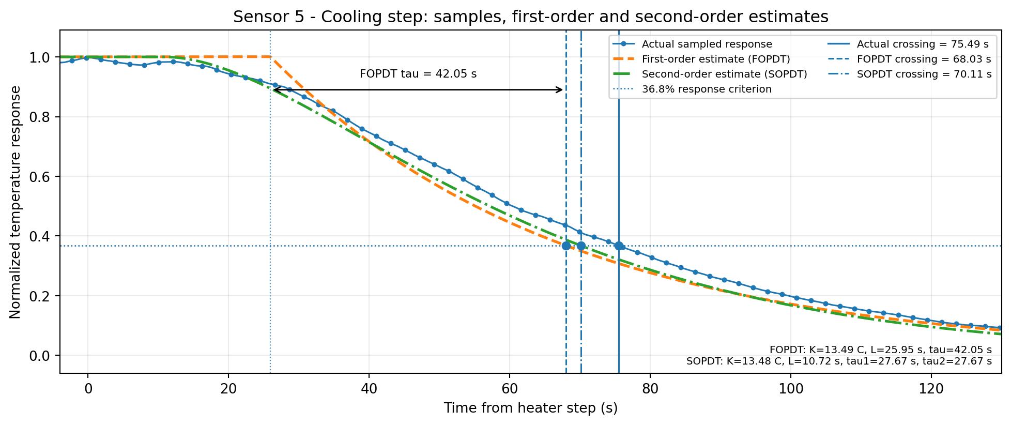
Figure 14. Sensor 5 cooling step. Actual sampled decay with FOPDT and SOPDT estimates; the 36.8% crossing times are marked.

5. Interpretation
Heating response. The 63.2% crossing time increases with sensor distance. Both model orders reproduce the trend. The first-order model is sufficient near Sensor 1, while the second-order model gives a modestly closer waveform match for the more distant sensors by representing an additional distributed thermal pole.
Cooling response. Cooling increasingly departs from a single-pole decay with distance. The SOPDT curves follow the sampled cooling transients more closely for Sensors 3-5, although residual long-term drift remains because the PCB is a distributed and mildly nonlinear thermal system.
Control implication. Use the FOPDT models for compact controller tuning and delay-aware control design. Use the SOPDT models with exact delay when simulation fidelity, distant-sensor prediction, or waveform reproduction is more important than model simplicity. When a tool requires a purely rational transfer function, use the SOPDT model with a Padé [2/2] delay; Padé [3/3] gives negligible additional improvement for this record.

Limitations
- The practical criterion times depend slightly on the smoothing interval and the selected pre-switch-off plateau window.
- The identified gain and dynamics are local to the tested 0-100% heater pulse, PCB mounting condition, ambient environment, and natural-convection state.
- The reported transfer functions describe the complete heater-to-temperature path. They are not the intrinsic time constants of the temperature-sensor ICs alone.
- Padé approximations can introduce a small nonphysical inverse response and should not be interpreted as an actual negative thermal excursion.
- Theoretical in this document refers to fitted FOPDT and SOPDT models, not finite-element or analytical heat-equation predictions.

6. Data products
Source recording: Setup2_Extended.txt
Model input files: setup2_transfer_function_parameters.csv and setup2_model_fits.csv
Generated comparison tables: setup2_time_constant_comparison_pade.csv and setup2_pade_delay_comparison.csv
Expanded model dataset: setup2_model_fits_with_pade.csv

